Day 3 – 20 Mar 2024

Spring Framework or Adv Spring Framework

40 hours training

Spring boot, Spring reactive modules, spring web client, spring with hibernate.

Spring transaction management, spring security etc.

Spring micro service

Spring MVC with ORM tool like Hibernate or JPA.

Before spring boot if we want to use any spring modules like spring core, context, orm, dao, aop, rest, security , testing etc.

We need to do lot of configuration using xml file and maintain dependencies.

But after spring boot we can do less configuration

Spring Boot

ORM

MVC

Spring MVC : Spring MVC is a module provided by spring framework which help to develop web application.

Model layer : java Bean , service class, dao class using jdbc or jdbctempalte, resource using xml file.

In DAO layer we can use ORM tools like hibernate or jpa etc.

Spring ORM doesn’t provide any orm tools. They allow us to integrate to existing orm tools like JPA or Hibernate.

Spring Data or Spring JPA Data (JPA data is base upon JPA).

1. Core JDBC
2. JdbcTemplate
3. JPA
4. Hibernate
5. Spring JPA Data

Spring MVC alone :

Servlet or JSP.

Tomcat 9.x or 10.x

In Spring MVC we can’t call any controller directly. According to Spring MVC we need to configure front controller in web.xml file or in java classes.

Front controller is a type of design pattern which control the flow of the application. Spring MVC internally provided pre defined class ie DispatcherServlet.

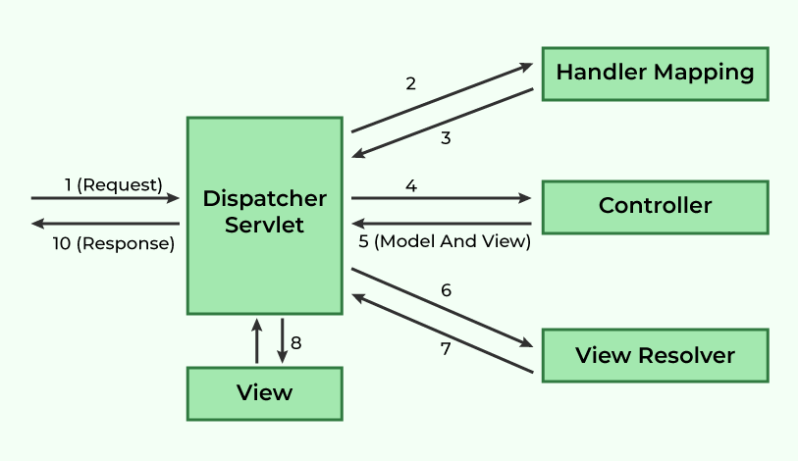

In spring MVC without spring boot we need to configure dispatcher servlet pre defined class in web.xml file or any configuration class.